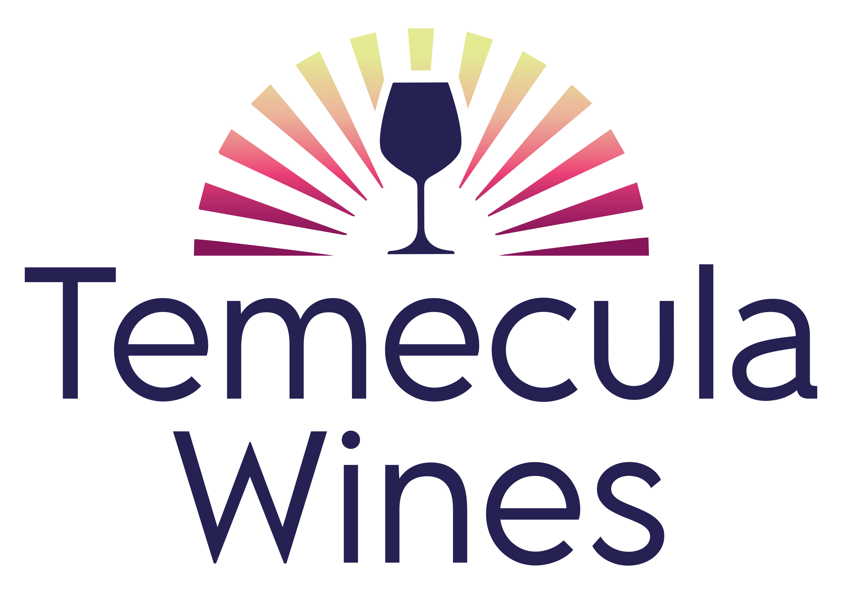

40th Annual Grape Day
Thursday, April 24, 2025
South Coast Winery Resort & Spa
Presenting Sponsor: American AgCredit

8:00 – 9:00am Vendor Exhibits, Registration, Continental Breakfast; Sponsored by Sunridge Nurseries

9:00 - 9:05am Welcome
Mike Rennie, TVWA President of the Board

9:05 – 9:15am Hall of Fame Scholarship Award & Hall of Fame Inductees
Mike Rennie, TVWA President of the Board

9:15 – 9:30am Riverside Ag Commissioner Presentation

9:30 – 10:00am Wine Institute – State of CA Wine

10:00 – 10:45am Climate Presentation
Daniel Cayan, Scripps Institute of Oceanography
10:45 – 11:05am Break, Vendor Exhibits

11:05 – 11:50am Regenerative & Sustainable Ag Practices
Steve Diver

12:10 – 1:00pm Vendor Exhibits and Lunch; Sponsored by The Vintner Vault

1:00 – 1:20pm Top Ten Things That a Winemaker Needs to Know/Do Going Into Harvest”
Jim Duane

1:20 – 1:45pm Best Practices for Barrel Sanitation/Aging & Maintenance
1:45 – 2:00pm Break, Vendor Exhibits

2:00 – 2:45pm Panel Discussion: Temecula Terroir – Examples that Express Temecula the Best – Moderator Shawn Richcreek, Total Wine
2:45 – 3:00pm Ensenada Tierra del Vino International Wine Competition Awards
3:00 – 4:00pm Regional Wine Tasting & Hors d’oeuvres
Temecula, Ramona, San Diego, Baja

